EE 210

HW#: 10

Last Name: **Aldacher**

First Name: **Muhammad**

ID: **011510317**

Date: **11/21/2020**

Assigned question #s: **9**

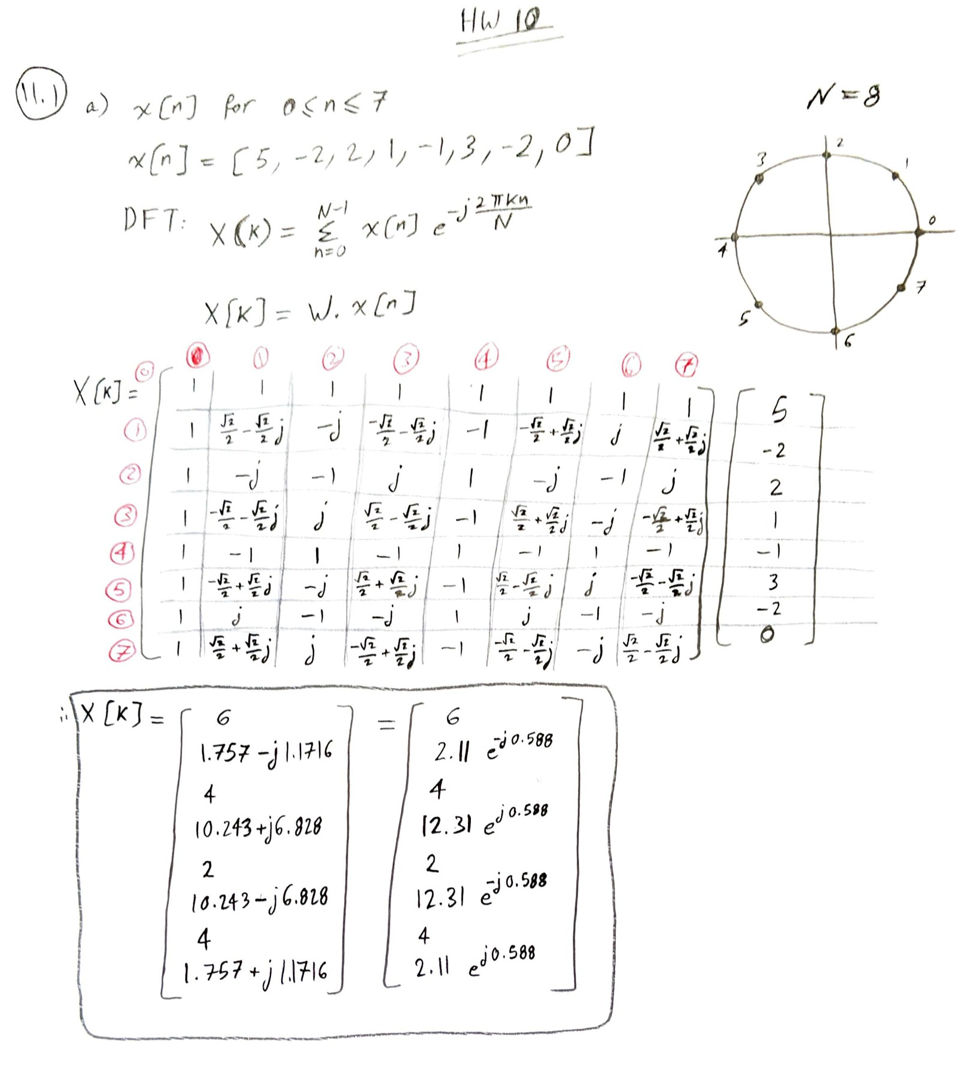

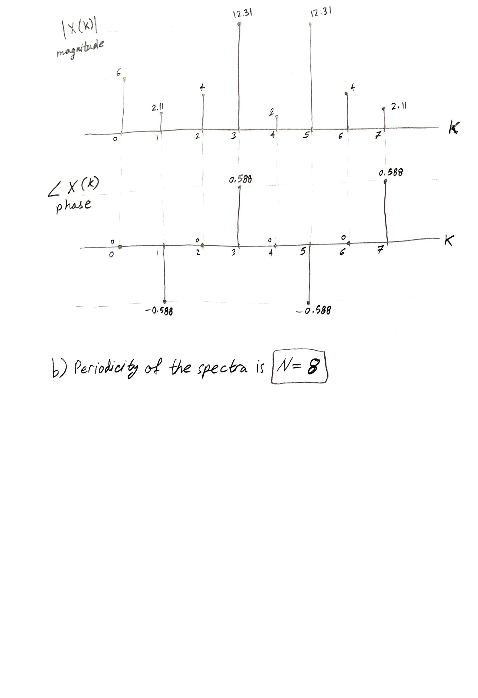

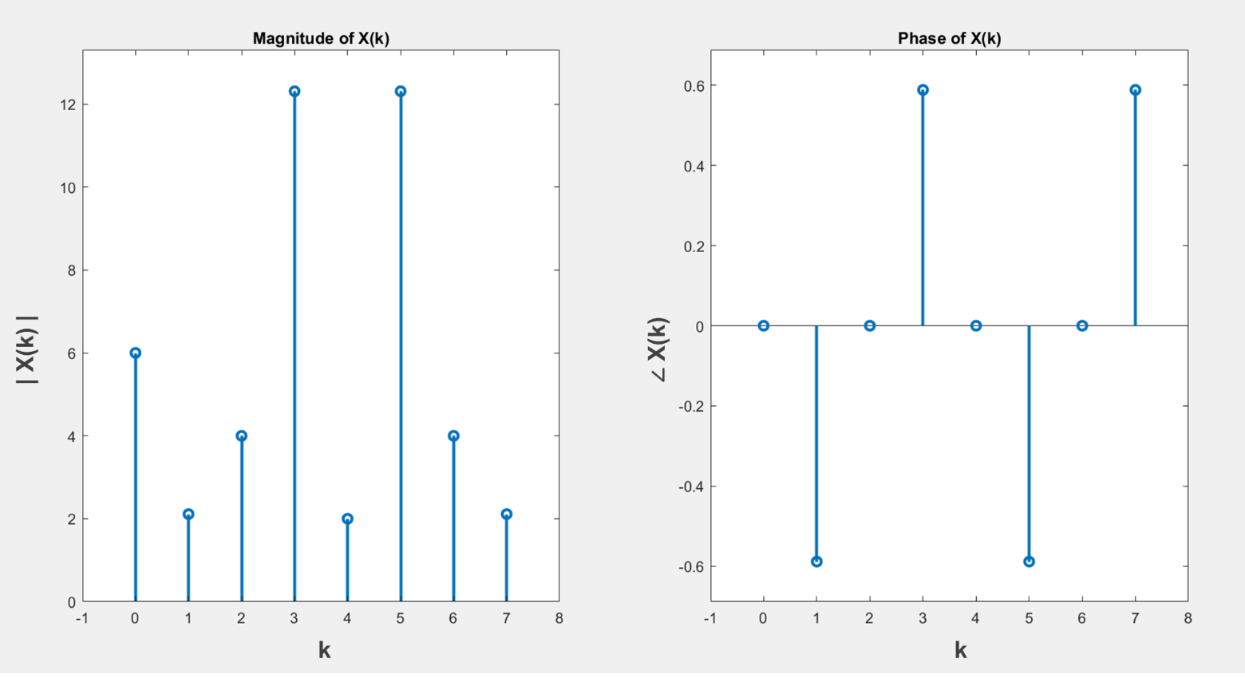

Matlab code for **Q 11.1**:

clc; clear all; close all;

x = [5 -2 2 1 -1 3 -2 0];

n = 0:1:length(x)-1;

%FFT N=8

X = fft(x);

%X' = ctranspose(X) which is the conjugate transpose

figure(1)

subplot(1,2,1); stem(n,abs(transpose(X)),'Linewidth',2); title('Magnitude of X(k)');

axis([-1 length(x) 0 max(abs(X))+1])

subplot(1,2,2); stem(n,angle(transpose(X)),'Linewidth',2); title('Phase of X(k)');

axis([-1 length(x) min(angle(X))-0.1 max(angle(X))+0.1])

xx = ifft(X)

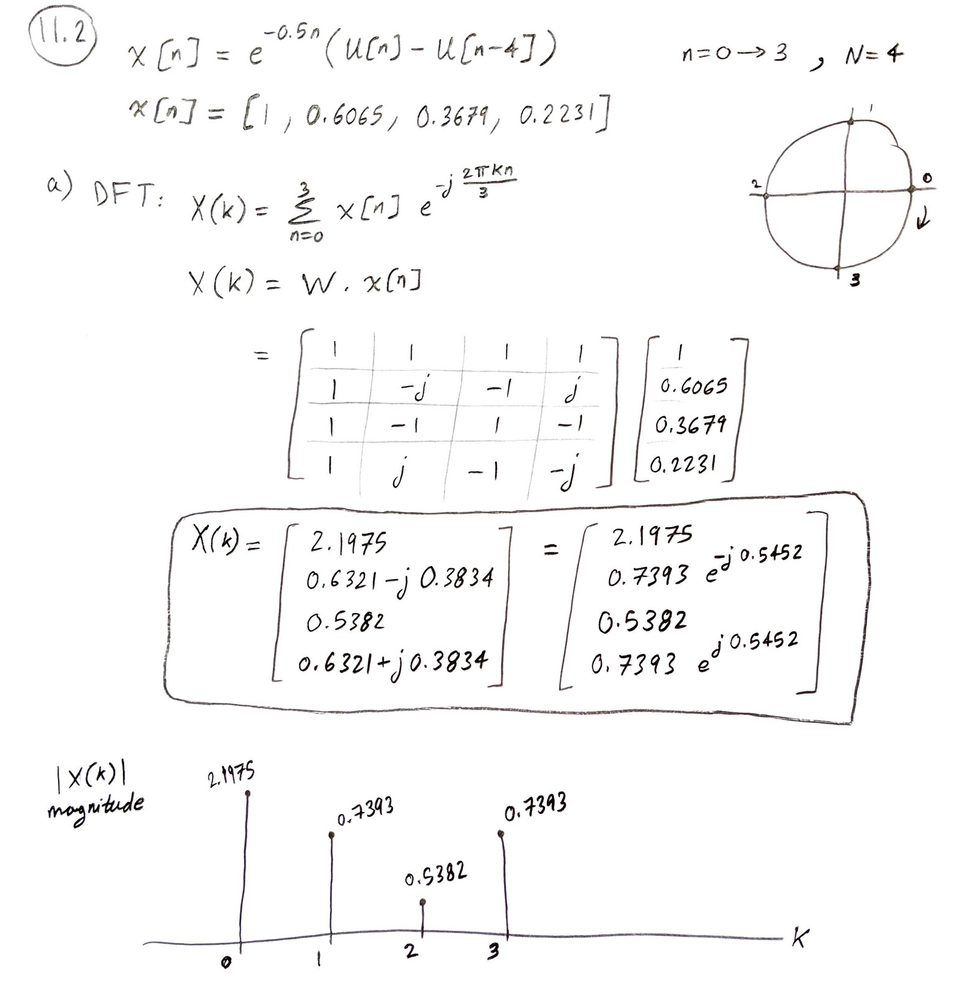

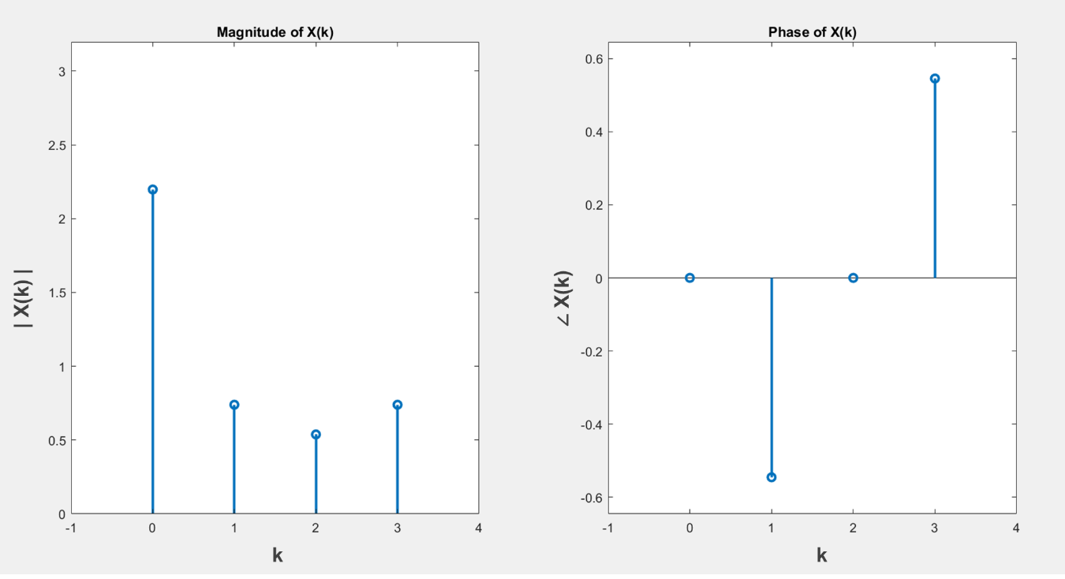

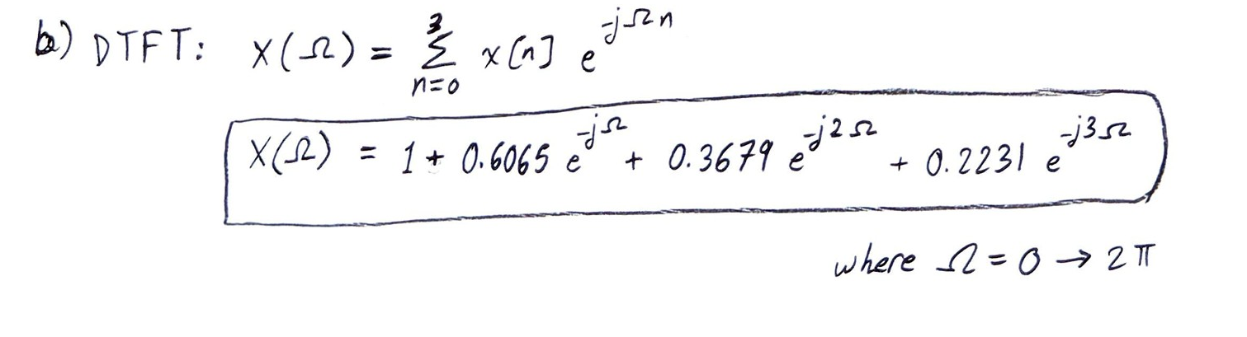

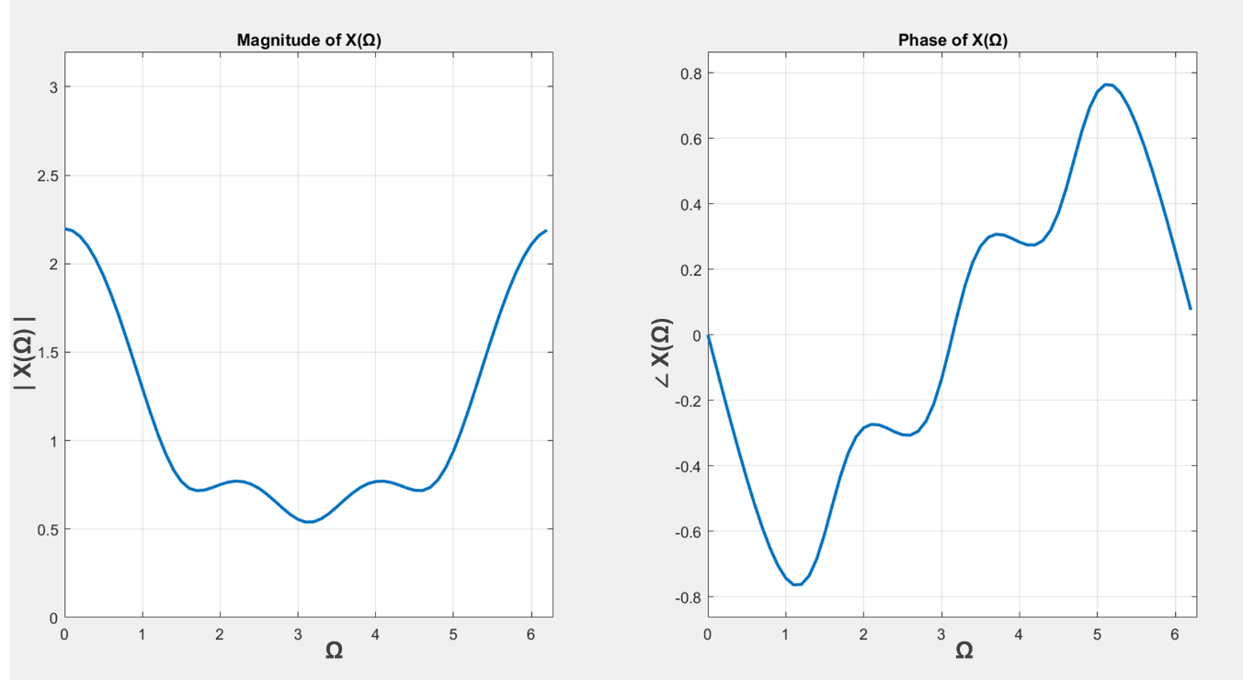

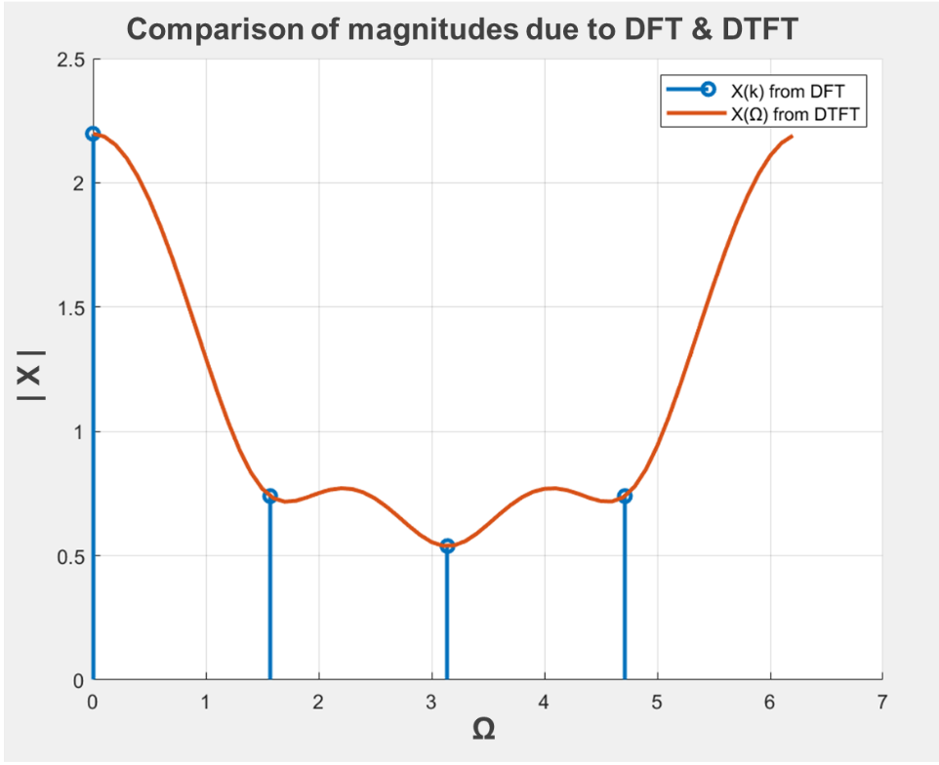

Matlab code for **Q 11.2**:

clc; clear all; close all;

%DFT

N = 4; n = 0:1:N-1;

x = exp(-0.5*n);

X = fft(x); X = transpose(X);

figure(1)

subplot(1,2,1); stem(n,abs(X),'Linewidth',2); title('Magnitude of X(k)');

axis([-1 length(x) 0 max(abs(X))+1])

subplot(1,2,2); stem(n,angle(X),'Linewidth',2); title('Phase of X(k)');

axis([-1 length(x) min(angle(X))-0.1 max(angle(X))+0.1])

xx = ifft(X)

%----------------------------------------------------

%DTFT

cnt=1;

for OM = 0:0.1:2*pi;

tmp =0;

for indx = 0:3;

tmp = tmp + x(indx+1)*exp(-j*OM*indx);

end

Xdtft(cnt) = tmp;

OM_V(cnt) = OM;

cnt = cnt+1;

end

figure(2)

subplot(1,2,1); plot(OM_V,abs(Xdtft),'Linewidth',2);

title('Magnitude of X('+string(char(937))+')');

axis([0 (2*pi) 0 max(abs(Xdtft))+1]); grid on

subplot(1,2,2); plot(OM_V,angle(Xdtft),'Linewidth',2);

title('Phase of X('+string(char(937))+')');

axis([0 (2*pi) min(angle(Xdtft))-0.1 max(angle(Xdtft))+0.1]); grid on

%----------------------------------------------------

%Comparison

figure; hold on; grid on;

n_new = (n*2*pi/N);

stem(n_new,abs(X),'Linewidth',2); plot(OM_V,abs(Xdtft),'Linewidth',2);

legend('X(k) from DFT','X('+string(char(937))+') from DTFT')

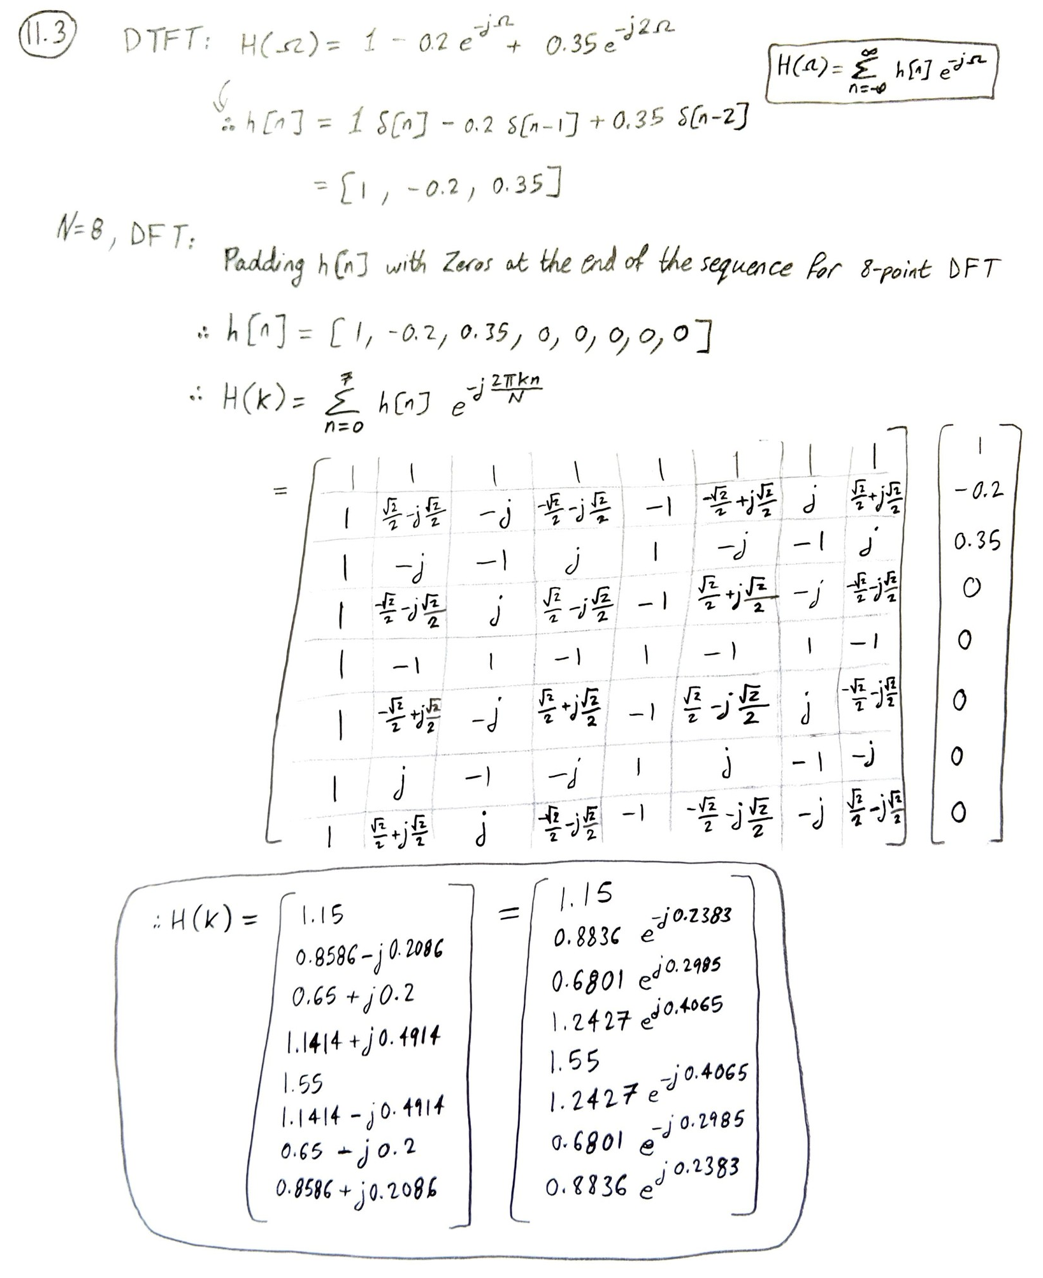

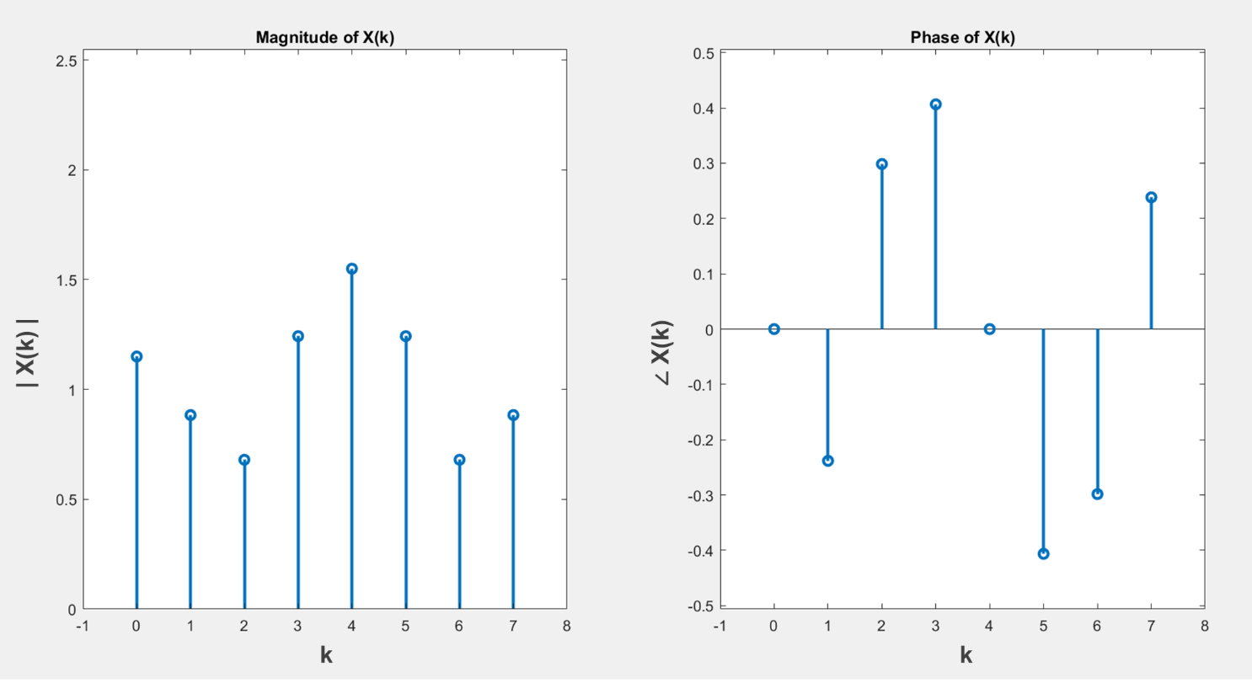

Matlab code for **Q 11.3**:

clc; clear all; close all;

%DFT

N = 8;

n = 0:1:N-1;

x = [1 -0.2 0.35];

%DFT N=8

X = fft(x,N); X=transpose(X)

figure(1)

subplot(1,2,1); stem(n,abs(X),'Linewidth',2); title('Magnitude of X(k)');

axis([-1 N 0 max(abs(X))+1])

subplot(1,2,2); stem(n,angle(X),'Linewidth',2); title('Phase of X(k)');

axis([-1 N min(angle(X))-0.1 max(angle(X))+0.1])

xx = ifft(X)

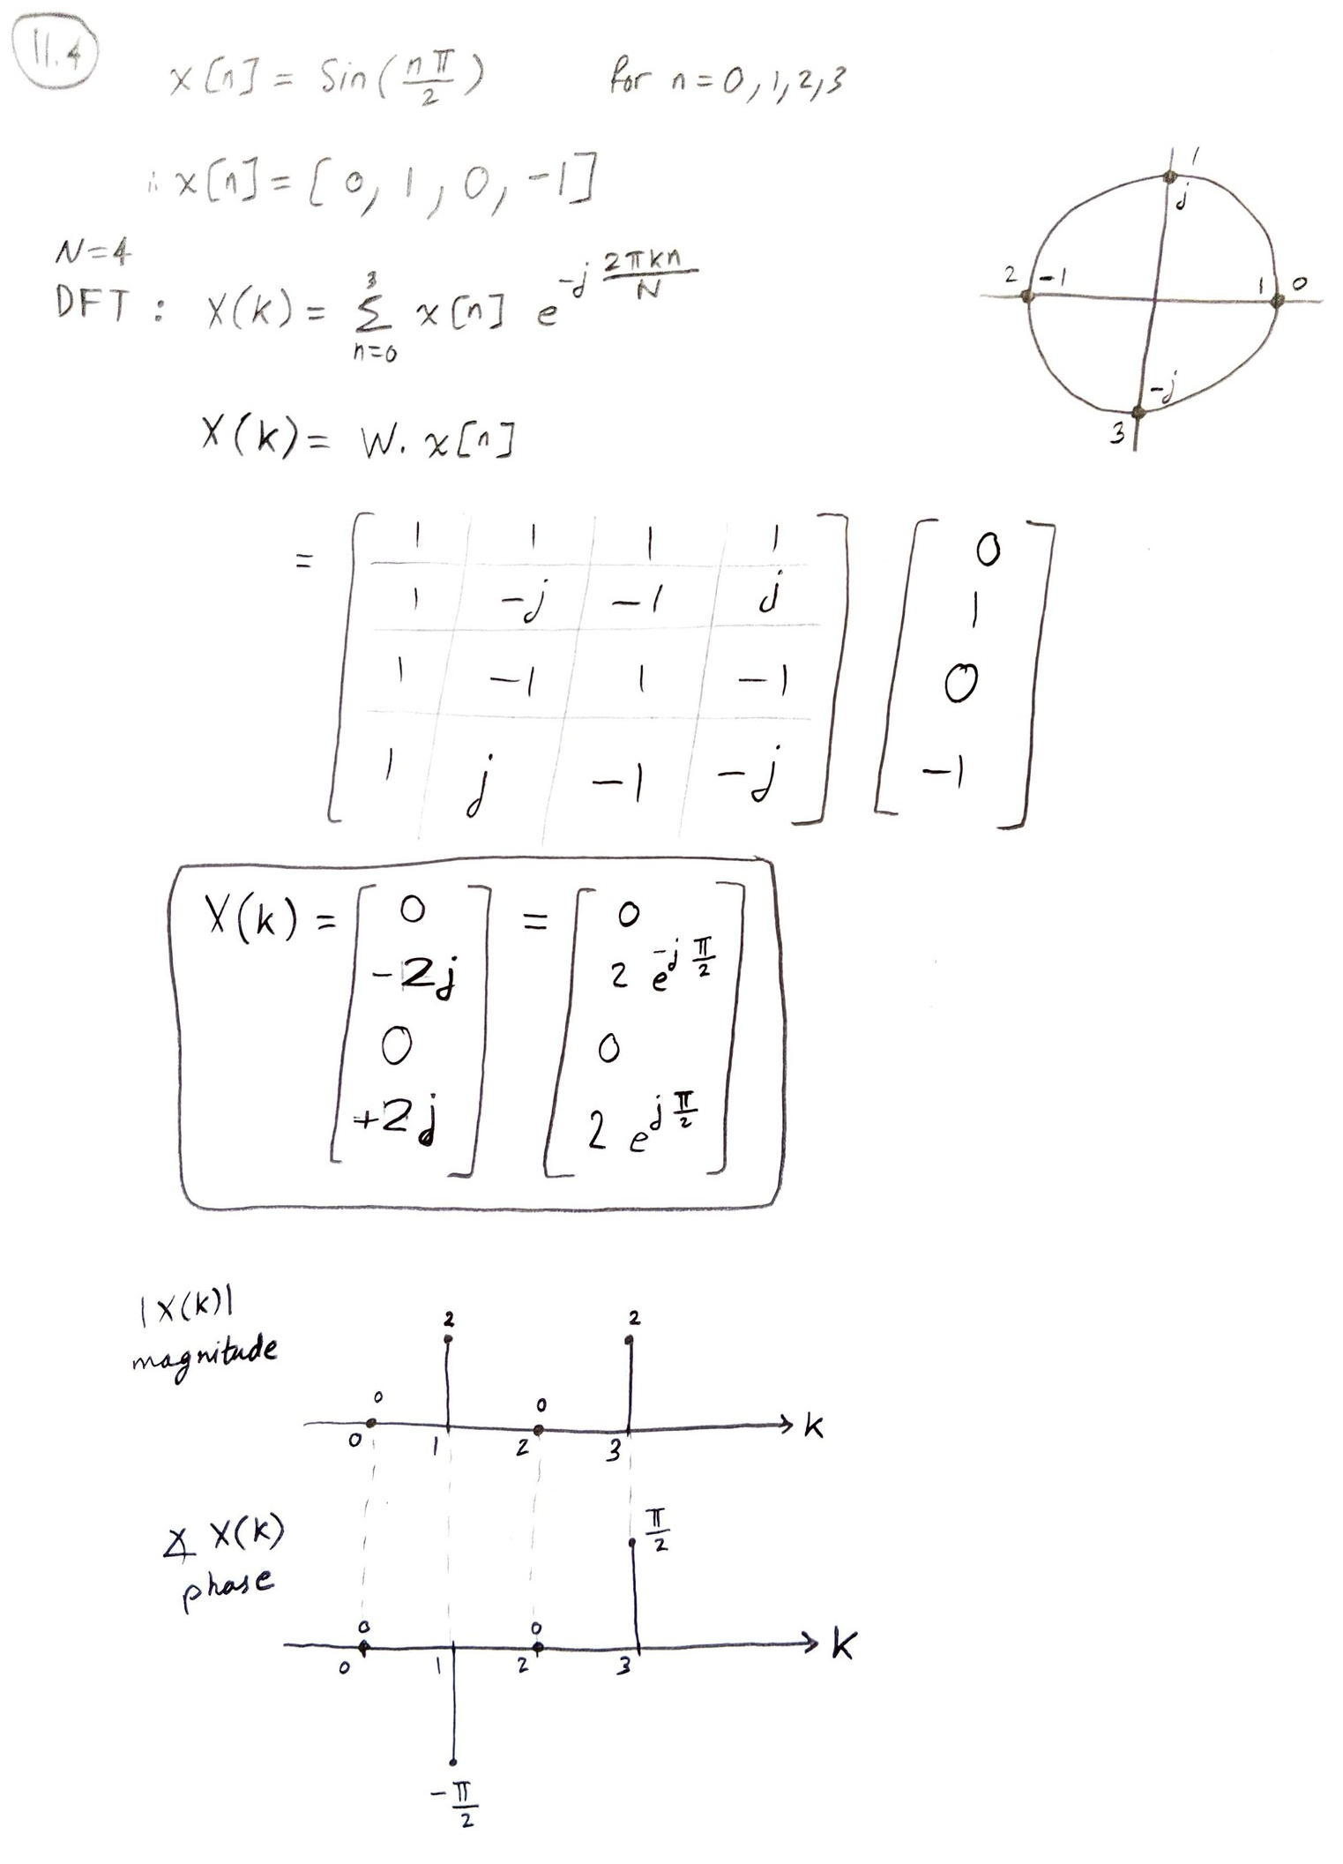

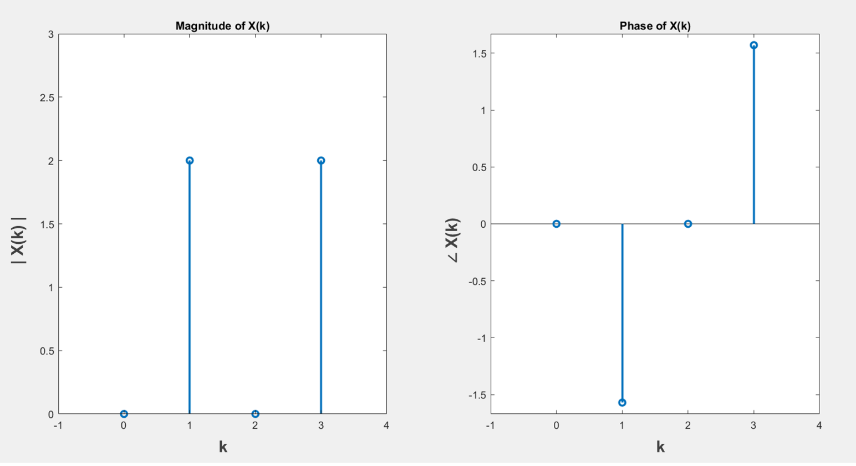

Matlab code for **Q 11.4**:

clc; clear all; close all;

%DFT

N = 4;

n = 0:1:N-1;

x = sin(n*pi/2);

%DFT N=4

X = fft(x); X = transpose(X)

figure(1)

subplot(1,2,1); stem(n,abs(X),'Linewidth',2); title('Magnitude of X(k)');

axis([-1 N 0 max(abs(X))+1])

subplot(1,2,2); stem(n,angle(X),'Linewidth',2); title('Phase of X(k)');

axis([-1 N min(angle(X))-0.1 max(angle(X))+0.1])

xx = ifft(X)

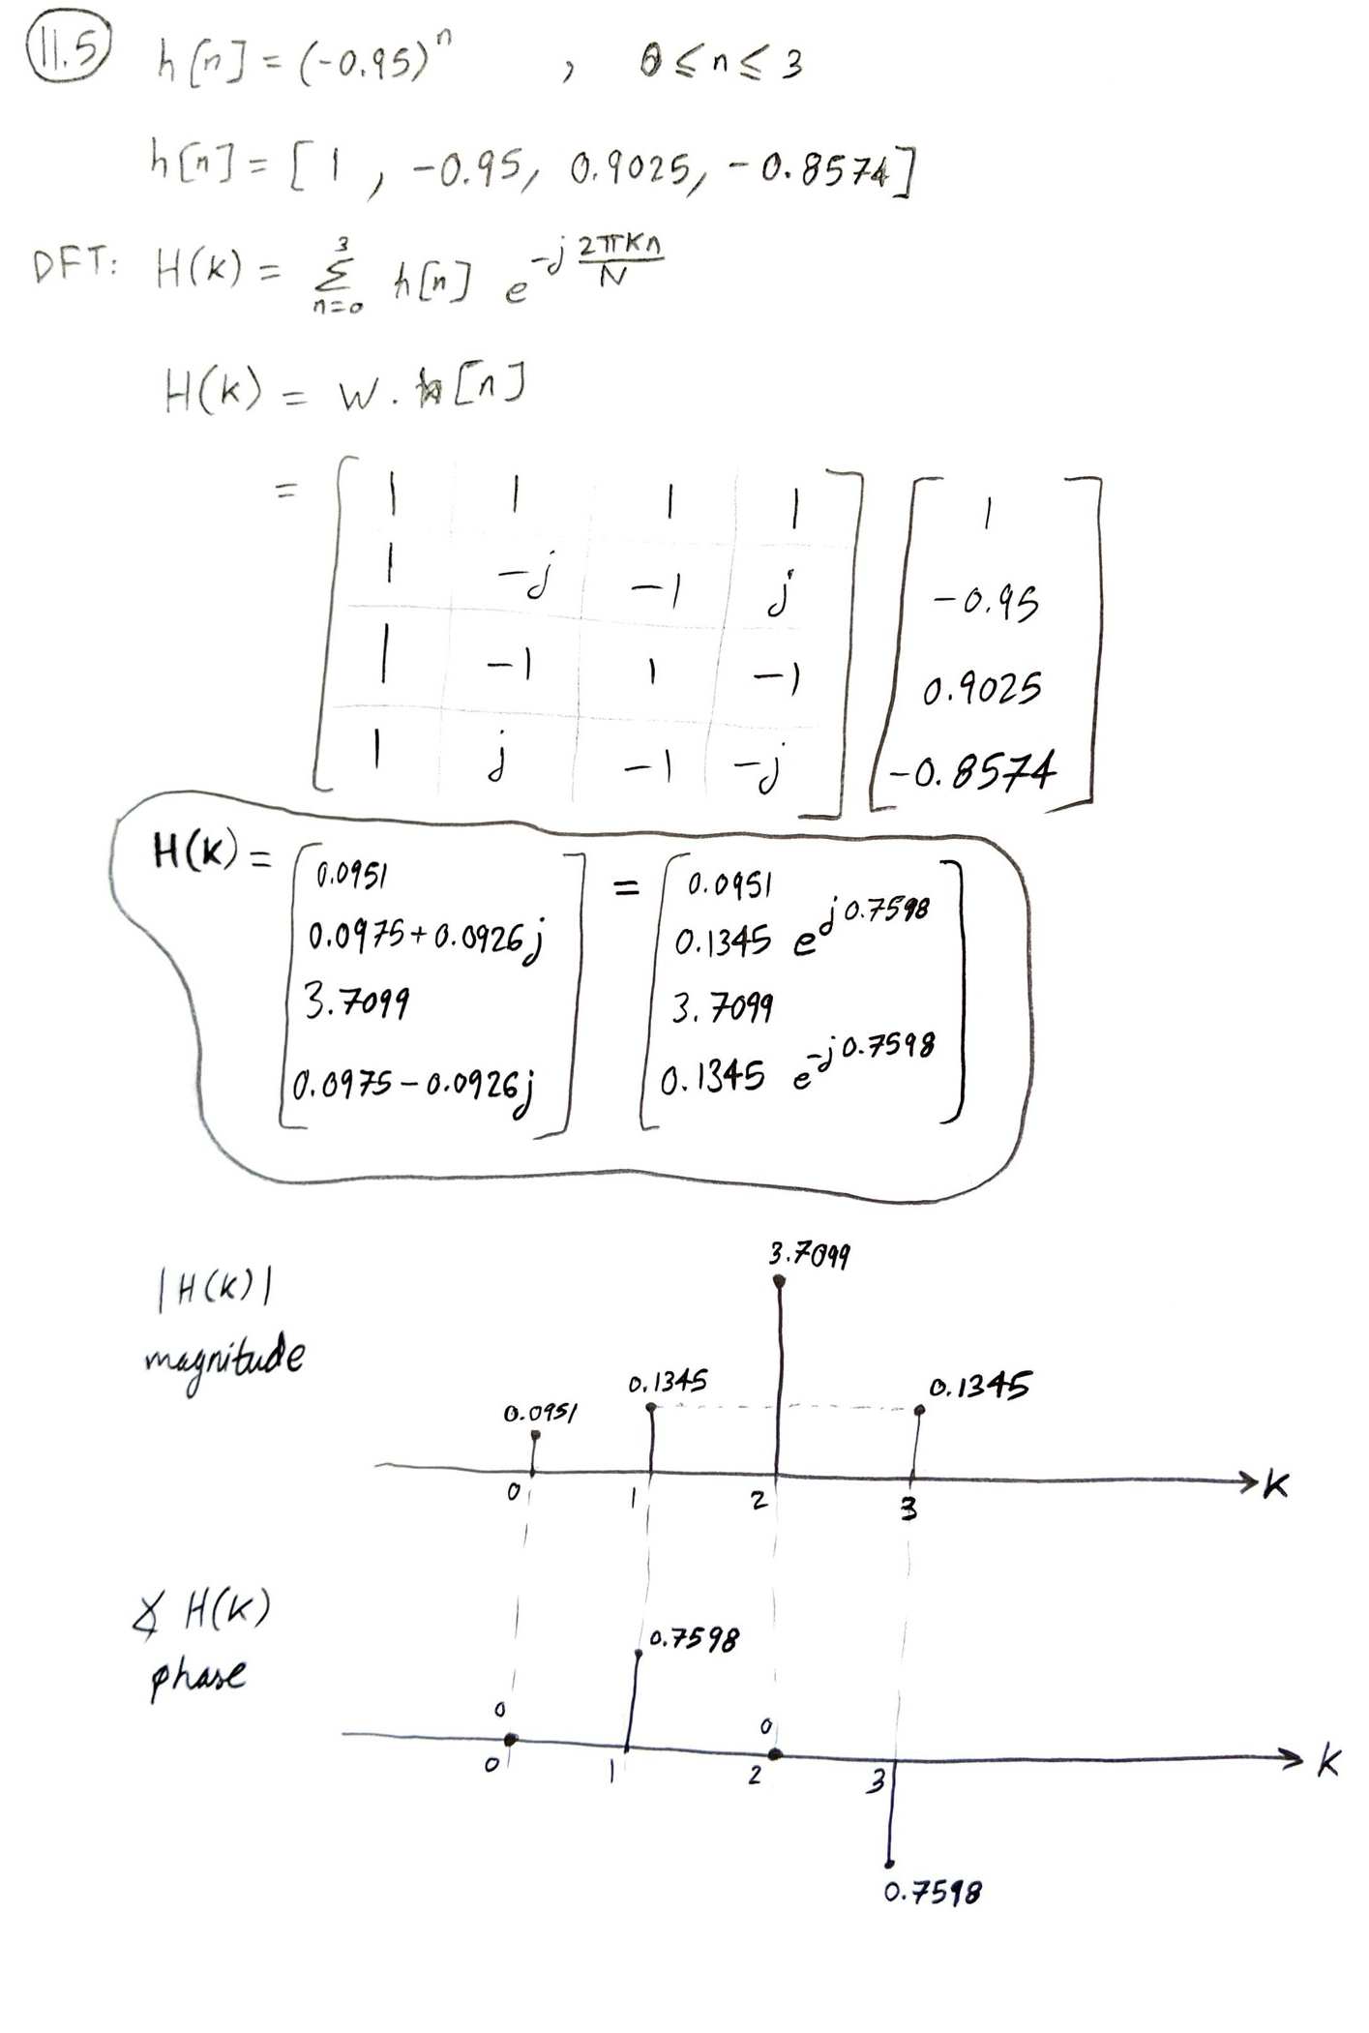

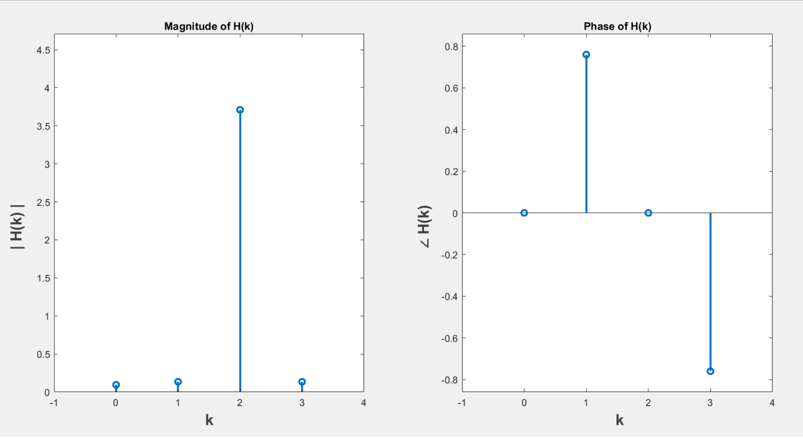

Matlab code for **Q 11.5**:

clc; clear all; close all;

%DFT

N = 4;

n = 0:1:N-1;

h = (-0.95).^n;

%DFT N=4

H = fft(h); H = transpose(H)

figure(1)

subplot(1,2,1); stem(n,abs(H),'Linewidth',2); title('Magnitude of H(k)');

axis([-1 N 0 max(abs(H))+1])

subplot(1,2,2); stem(n,angle(H),'Linewidth',2); title('Phase of H(k)');

axis([-1 N min(angle(H))-0.1 max(angle(H))+0.1])

hh = ifft(H)

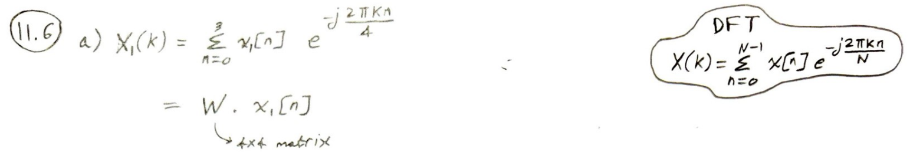

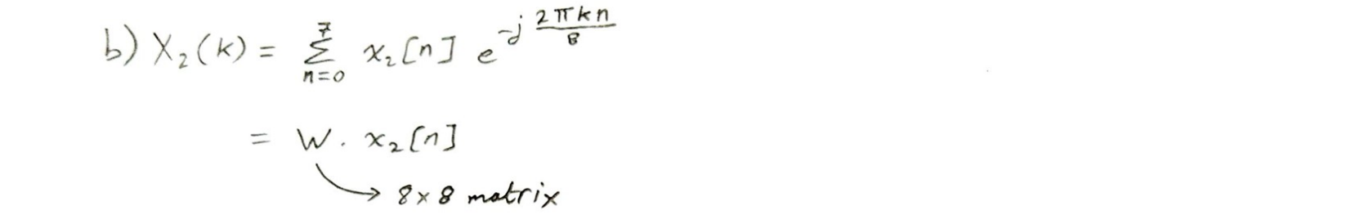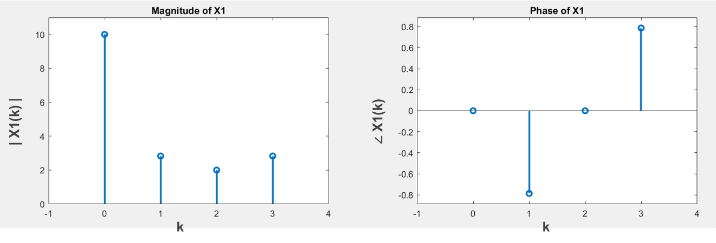

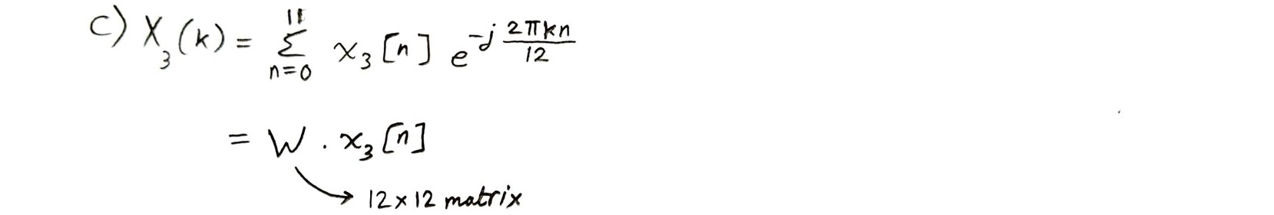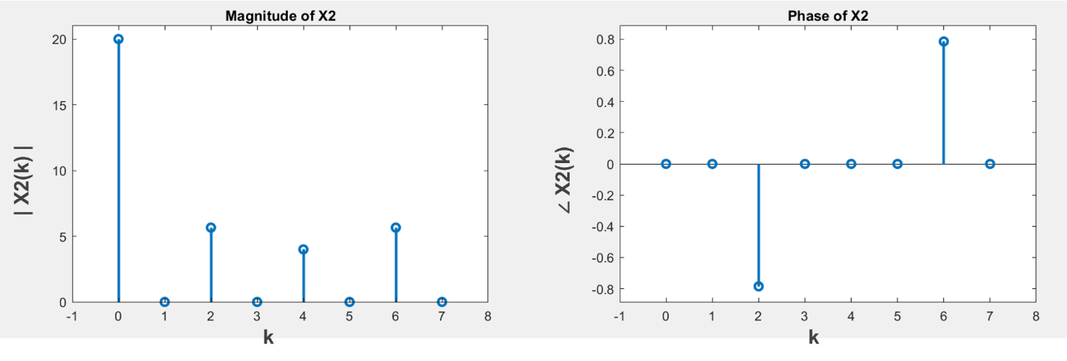

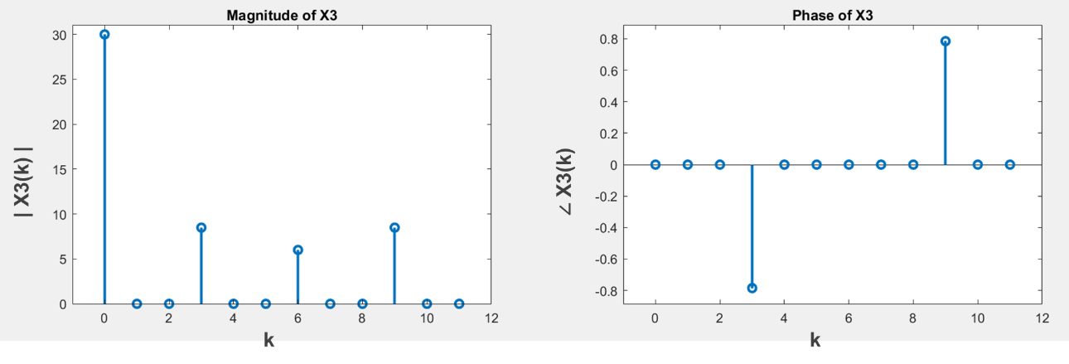

Matlab code for **Q 11.6**:

clc; clear all; close all;

x1 = [4 3 2 1]; N1 = length(x1);

x2 = [x1 x1]; N2 = length(x2);

x3 = [x1 x1 x1]; N3 = length(x3);

n1 = 0:1:((N1)-1);

n2 = 0:1:((N2)-1);

n3 = 0:1:((N3)-1);

%DFT

X1 = fft(x1); X1 = transpose(X1);

X2 = fft(x2); X2 = transpose(X2);

X3 = fft(x3); X3 = transpose(X3);

figure(1)

subplot(1,2,1); stem(n1,abs(X1),'Linewidth',2); title('Magnitude of X1');

axis([-1 N1 0 max(abs(X1))+1])

subplot(1,2,2); stem(n1,angle(X1),'Linewidth',2); title('Phase of X1');

axis([-1 N1 min(angle(X1))-0.1 max(angle(X1))+0.1])

figure(2)

subplot(1,2,1); stem(n2,abs(X2),'Linewidth',2); title('Magnitude of X2');

axis([-1 N2 0 max(abs(X2))+1])

subplot(1,2,2); stem(n2,angle(X2),'Linewidth',2); title('Phase of X2');

axis([-1 N2 min(angle(X2))-0.1 max(angle(X2))+0.1])

figure(3)

subplot(1,2,1); stem(n3,abs(X3),'Linewidth',2); title('Magnitude of X3');

axis([-1 N3 0 max(abs(X3))+1])

subplot(1,2,2); stem(n3,angle(X3),'Linewidth',2); title('Phase of X3');

axis([-1 N3 min(angle(X3))-0.1 max(angle(X3))+0.1])

%figure; hold on; stem(abs(X1)); stem(abs(X2)); stem(abs(X3));

%figure; hold on; stem(angle(X1)); angle(abs(X2)); angle(abs(X3));

xx1 = ifft(X1);

xx2 = ifft(X2);

xx3 = ifft(X3);

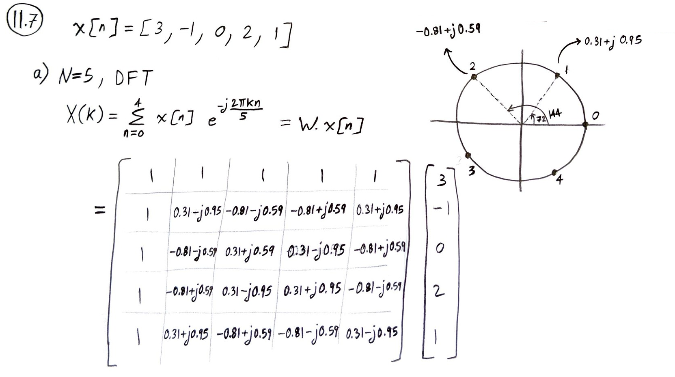

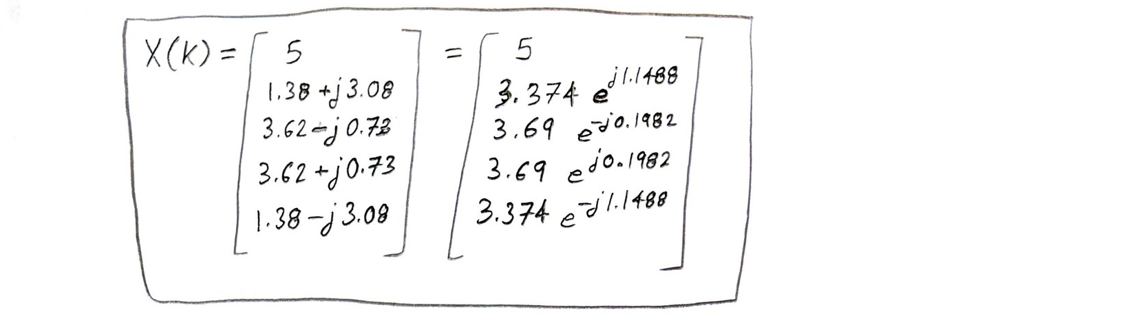

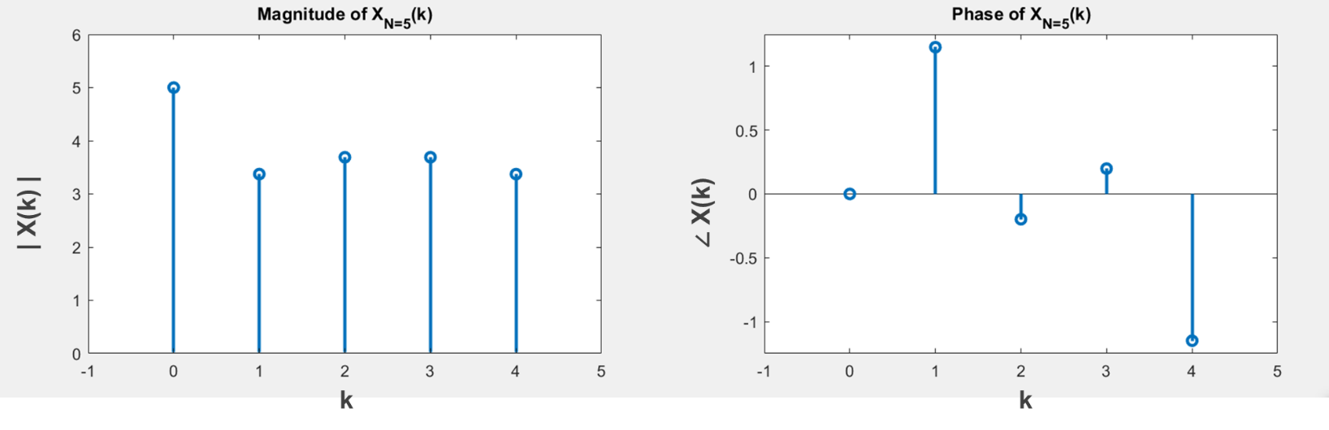

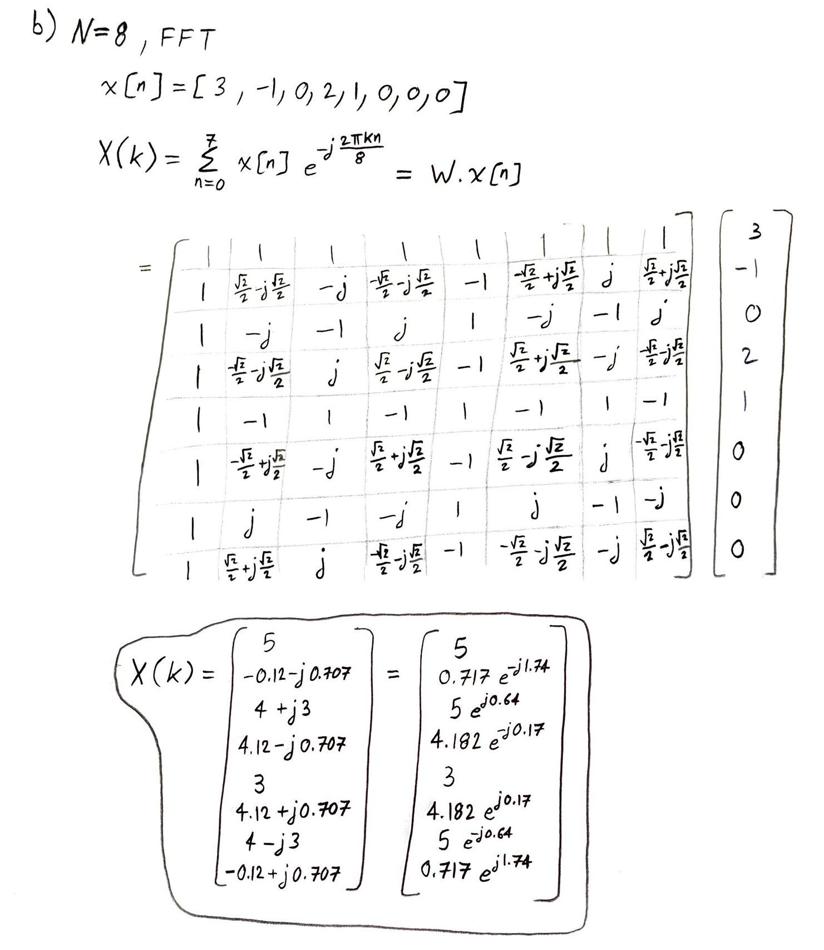

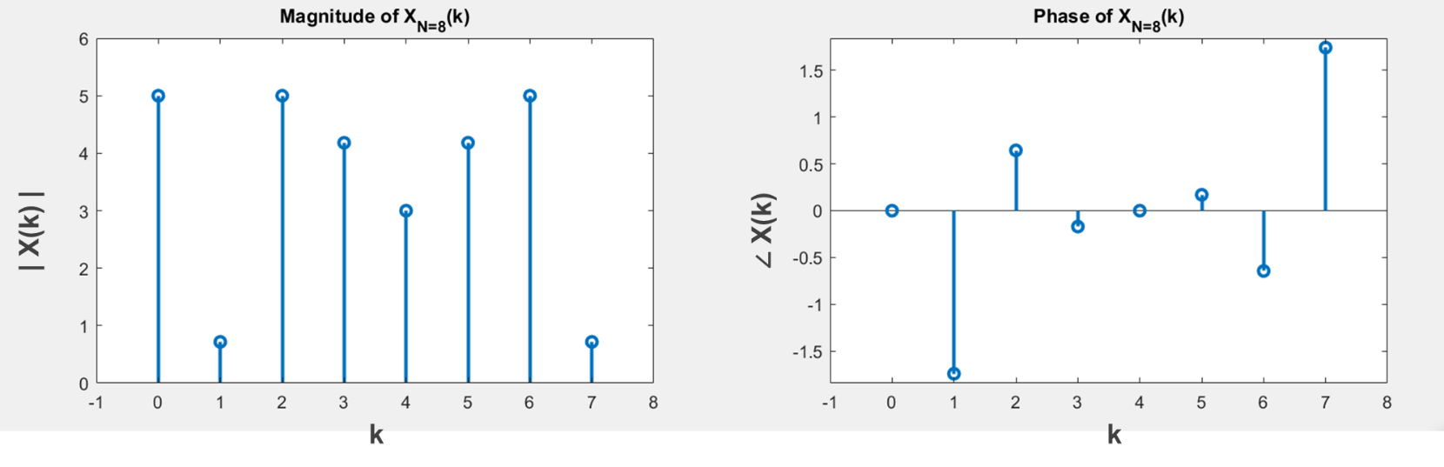

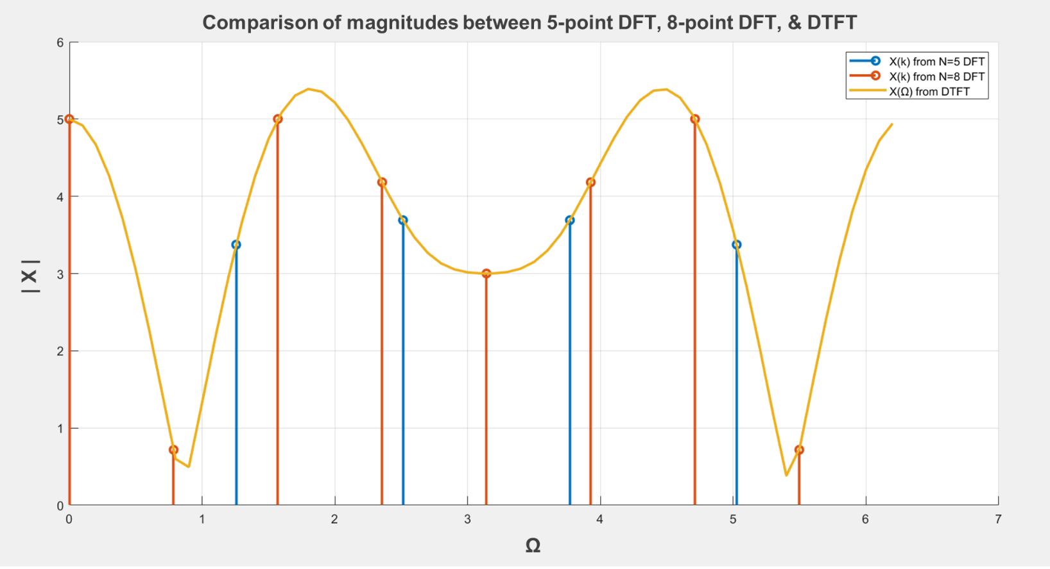

Matlab code for **Q 11.7**:

clc; clear all; close all;

%DFT

N1 = 5;

n1 = 0:1:N1-1;

x1 = [3 -1 0 2 1];

X1 = fft(x1); X1 = transpose(X1)

figure(1)

subplot(1,2,1); stem(n1,abs(X1),'Linewidth',2); title('Magnitude of X_N_=_5(k)');

axis([-1 N1 0 max(abs(X1))+1])

subplot(1,2,2); stem(n1,angle(X1),'Linewidth',2); title('Phase of X_N_=_5(k)');

axis([-1 N1 min(angle(X1))-0.1 max(angle(X1))+0.1])

xx1 = ifft(X1)

%FFT

N2 = 8;

n2 = 0:1:N2-1;

x2 = [3 -1 0 2 1 0 0 0];

X2 = fft(x2); X2 = transpose(X2)

figure(2)

subplot(1,2,1); stem(n2,abs(X2),'Linewidth',2); title('Magnitude of X_N_=_8(k)');

axis([-1 N2 0 max(abs(X2))+1])

subplot(1,2,2); stem(n2,angle(X2),'Linewidth',2); title('Phase of X_N_=_8(k)');

axis([-1 N2 min(angle(X2))-0.1 max(angle(X2))+0.1])

xx2 = ifft(X2)

%DTFT

cnt=1;

for OM = 0:0.1:2*pi;

tmp =0;

for indx = 0:length(x1)-1;

tmp = tmp + x1(indx+1)*exp(-j*OM*indx);

end

Xdtft(cnt) = tmp;

OM_V(cnt) = OM;

cnt = cnt+1;

end

figure(3)

subplot(1,2,1); plot(OM_V,abs(Xdtft),'Linewidth',2); title('Magnitude of X('+string(char(937))+')');

axis([0 (2*pi) 0 max(abs(Xdtft))+1]); grid on

subplot(1,2,2); plot(OM_V,angle(Xdtft),'Linewidth',2); title('Phase of X('+string(char(937))+')');

axis([0 (2*pi) min(angle(Xdtft))-0.1 max(angle(Xdtft))+0.1]); grid on

%----------------------------------------------------

%Comparison

figure; hold on; grid on;

n1_new = (n1*2*pi/N1);

stem(n1_new,abs(X1),'Linewidth',2);

n2_new = (n2*2*pi/N2);

stem(n2_new,abs(X2),'Linewidth',2);

plot(OM_V,abs(Xdtft),'Linewidth',2);

legend('X(k) from N=5 DFT','X(k) from N=8 DFT','X('+string(char(937))+') from DTFT')

